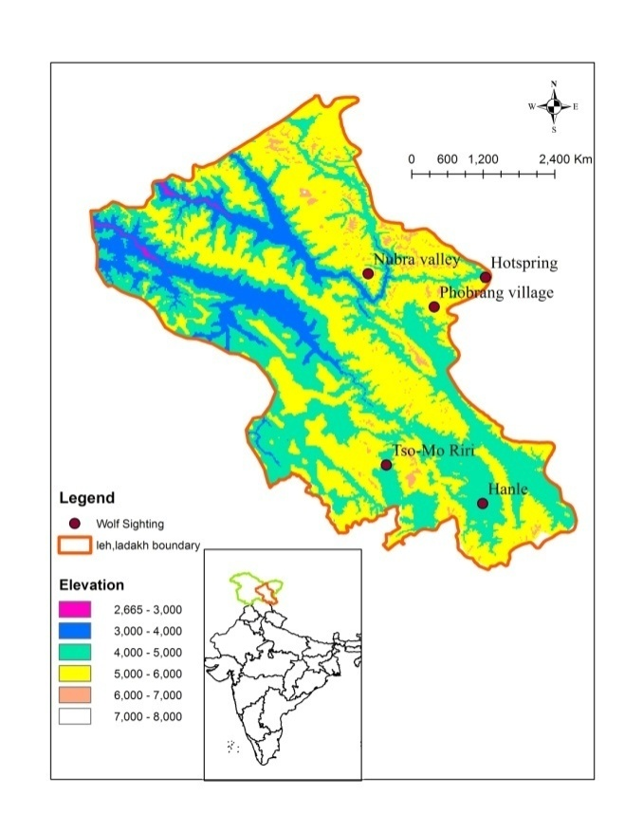

FF
Fig. 1: Map showing the sighting records of Tibetan wolf and Black Tibetan Wolf in Ladakh, India

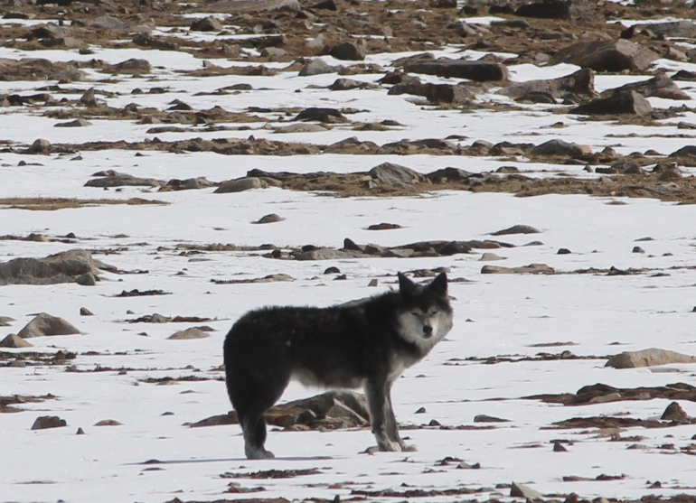

Figure 2. Black Tibetan wolf Sighted at Marsemik la, Changchenmo Valley, Changthang WLS, Ladakh.

Fig. 1: Map showing the sighting records of Tibetan wolf and Black Tibetan Wolf in Ladakh

